SISO/UFI Deeper Dive: Case Study on
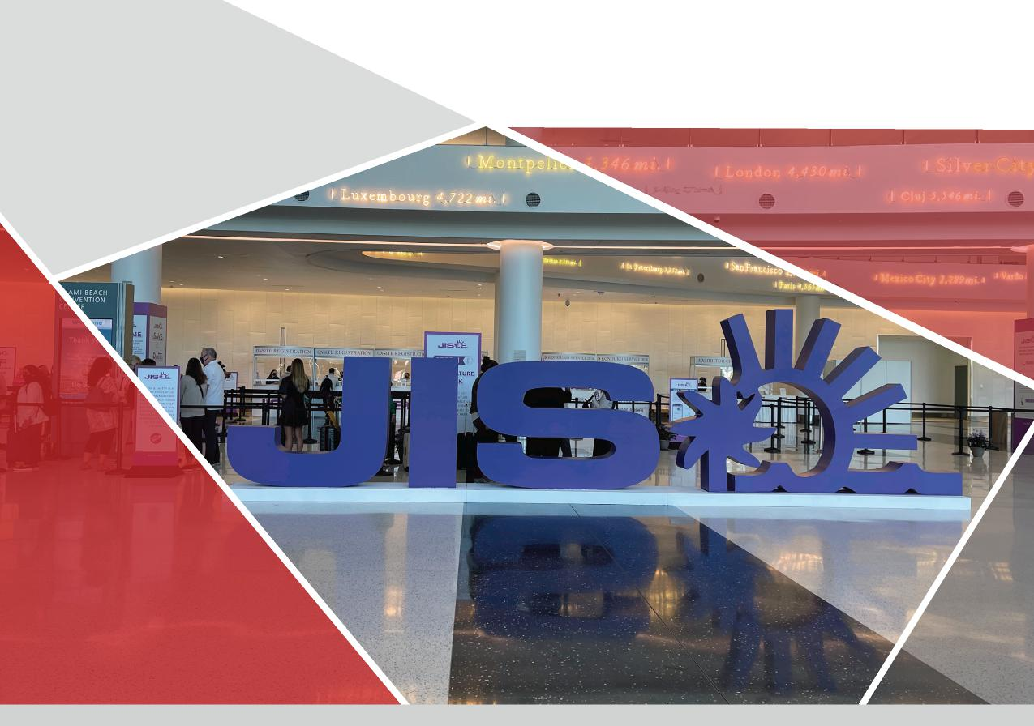
Case Study
Jewelers International Showcase
Reed Exhibitions USA safely produces
its first show in the U.S. since the pandemic

May 2021

Contents
Overview 03
Context: One year with virtually no revenue 05
Florida: Open for Business 05
Priority No 1: Health and Safety 06
Attendee Experience 08
Exhibitors: Happy to be F2F 09
What’s next 11
What was new and different at JIS March 12
Jewelers International Showcase (JIS) was the first show for Reed Exhibitions in the U.S. and the first show at the Miami Beach Convention Center (MBCC) since the pandemic.

SISO/UFI Deeper Dive: Case Study on Jewerlers International Showcase

SISO/UFI Deeper Dive: Case Study on Jewerlers International Showcase
Overview
When PAX Boston closed on March 1, 2020, the impacts of COVID-19 were already coming to the fore. The B2C show was the last event produced in the U.S. before the pandemic by Reed Exhibitions USA, a division of Reed Exhibitions (RX), one of the largest global organizers with 400+ shows annually. On March 22, RX USA got back into the live face-to-face (F2F) channel when it safely opened the trade-only 2021 Jewelers International Showcase (JIS) at the Miami Beach Convention Center.
“Although the jewelry industry has remained strong through the pandemic and jewelry sales have performed well, buyers still need to see jewelry in person, and be able to touch, feel, and try on the pieces before committing to merchandise they’ll stock in their stores,” said Tuchband. “We are so pleased that we were able to bring the unique jewelry markets JIS represents together again to provide in-person networking and business after an unprecedented year, while keeping health and safety top-of-mind for a productive show experience.”
Held in Miami since it launched in 1979, JIS is typically held twice a year in January and October, with the last show taking place Feb. 9-11, 2020, immediately following Super Bowl LIV in Miami. The show usually takes place in January but was moved to early February to avoid conflicting with the Super Bowl-related events happening at the convention center.
RX had the opportunity to put its new health and safety measures into practice. “Standardization was difficult, but we started by creating a task force within RX comprised of stakeholders from across the entire business, not simply operations,” said Mike Grant, Senior VP, Operations Group, RX USA. “We had representation from sales, marketing, conference, and other critical staffers who understood the different specifications within the business. We crafted our plans relative to the
After rescheduling and pushing back the 2021 event to later in the calendar, JIS March attracted nearly 3,000 buyers and 170 exhibitors from across the U.S. Attendees included independently owned jewelry retailers, boutiques, online and specialty retail buyers, as well as designers, diamond dealers, pawn brokers, wholesale buyers, and distributors. The largest booths included companies like Alishaev Bros AY, Inc., Gold-N-Diamonds Inc. Jewelry, A.V. Diamonds and ABM Gold & Diamond. Total attendance was up 10%, with some 15% of visitors coming from outside the U.S., said Jordan Tuchband, Industry Vice President of JIS Events.
Show Dates & Location
Jewelers International Showcase (JIS)
March 22-24, 2021
Miami Beach Convention Center
Miami Beach, FL
www.SISO.org | www.UFI.org
3

SISO/UFI Deeper Dive: Case Study on Jewerlers International Showcase

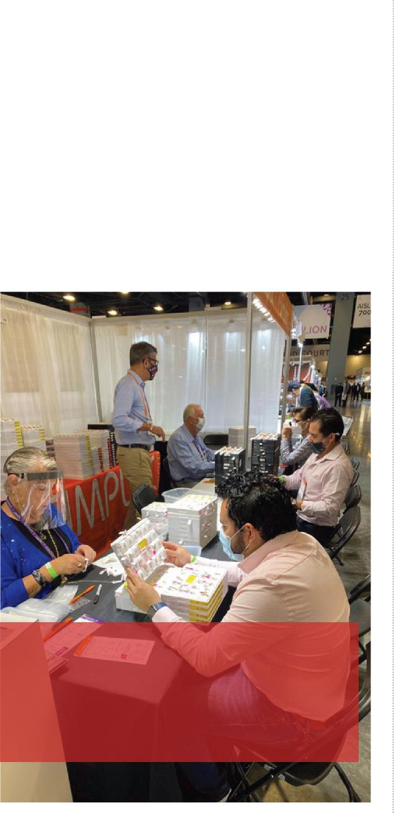
jewelry store is in a tourist destination, so we had a great year,” said Lynne Ballerini, a buyer from Michael’s Jewelry Inc., a store in Chincoteague Island, VA, which is within driving distance for much of the highly populated East Coast region.
pre-show, on-site, post show experiences. We felt the need to develop our own enhanced protocols and mission statements above and beyond what was being put out by the industry.”
The impact of COVID on the jewelry sector was mixed, but it fared better than some industries during the pandemic. Consumers did spend money on jewelry since they weren’t taking any big trips abroad. While U.S. consumers weren’t typically going abroad during the pandemic, many urban residents flocked to tourist destinations — especially those within driving distance. “Our
“Although the jewelry industry has remained strong through the pandemic and jewelry sales have performed well, buyers still need to see jewelry in person, and be able to touch, feel, and try on the pieces before committing to merchandise they’ll stock in their stores.” Jordan Tuchband, Industry VP - JIS Events
Miami Beach Mayor Dan Gelber welcomed the JIS team and RX executives who attended the event. “This event is a good appetizer of what’s to come,” said Gelber. “A lot of people want to be here ... almost too many. For the last 41 years, the show’s impact to the city has not been insignificant. Because of the pandemic, it’s even more significant — if not symbolic.”
“The economic impact of JIS to the city of Miami Beach is in excess of $2 million,” said William Talbert III, CDME, President and CEO, Greater Miami Convention & Visitors Bureau (GMCVB). “It’s one of the most important events in our community each year.”
Gelber added: “It’s a very heartening thing to see shows start up again. We are a hospitality town, and our economic engine is about gathering and people getting together.”
Hugh Jones, Global CEO of Reed Exhibitions, attended his first face-to-face event since he joined the company in February 2020. “It has been a very hard year for all our customers, visitors and our teams, but I’m delighted to say that physical events are back,” he said. “Exhibitions and trade shows are key to the growth of business and the local economies in which they take place. JIS was alive with the excitement and buzz that comes from meeting friends, colleagues, and business partners once more, and all those present were

www.SISO.org | www.UFI.org 4

SISO/UFI Deeper Dive: Case Study on Jewerlers International Showcase

produced events in Asia and Australia since the pandemic, RX was hit financially because of so many event cancellations around the globe in 2020 and early 2021. According to RELX’s 2020 year-end financial results: “The Exhibitions business, which accounted for 5% of the group total in the year (down from 16% in 2019), was significantly impacted by COVID-19 in 2020, with revenue of £362m (£1,269m). Exhibitions moved into an adjusted loss of £164m (£331m profit).”
“For the last 41 years, the show’s impact to the city has not been insignificant. Because of the pandemic, it’s even more significant – if not symbolic.” Miami Beach Mayor Dan Gelber
playing their part in complying with our health and safety protocols to the benefit of all. It was humbling to witness.”
In this white paper, SISO and UFI take a deeper dive into how the event was produced safely. SISO was on the ground in-person to interview RX show staff and the executive team, key CVB staff, the Miami Beach Mayor, the convention center GM, contractors, exhibitors, and attendees.
Context: One year with virtually no revenue
While the company, owned by RELX, has
That meant tough calls by the operations team and all of RX’s leadership. “As a responsible company, we had to implement necessary cost reductions,” said Grant. “Pre-pandemic, Reed Exhibitions USA produced upwards of 50 shows, but we had to make the decision to sunset several events in order to focus our resources moving forward.”
Fernando Fischer, President, Americas, Reed Exhibitions, said: “The good news is that 85% of our customers are booked for 2021, and we are making a push for the final 15%. We are less concerned about size and more concerned with brands and helping them to grow.”
Florida: Open for Business
With fewer government restrictions on capacity limits and gatherings, the state of Florida is one of the few states that has hosted a number of trade shows in early 2021. Last September, the MBCC earned the Global Biorisk Advisory Council® (GBAC) STARTM Facility Accreditation, a standard for facilities and venues worldwide. Under the guidance of GBAC (a division of ISSA, the

www.SISO.org | www.UFI.org 5

SISO/UFI Deeper Dive: Case Study on Jewerlers International Showcase

worldwide cleaning industry association), MBCC has implemented the stringent protocols and staff training for cleaning, disinfection, and infectious disease prevention.
“The health, safety, and security of the Miami Beach Convention Center and all who enter is our top priority,” said MBCC General Manager Freddie Peterson. “By deploying strict cleaning, disinfection, and staff training protocols, we set the stage for a healthy return to live events and continuing our commitment to excellence in venue management. We are thrilled to have ISSA/ GBAC’s third-party independent accreditation as this further instills confidence amongst our teams, clients and guests while further positioning the MBCC for continued success.”
Since the state has been more open than other destinations, Florida has attracted a greater number of leisure travelers, especially during spring break. As JIS was moving in and setting up over the weekend, crowds of spring break revelers descended on South Beach, several blocks from the convention center.
On March 20 — two days before the show opened — Mayor Gelber declared a state of emergency due to overwhelming spring break crowds, imposing an 8 p.m. curfew for its entertainment district and temporarily closing the surrounding area to traffic at night. Show management and the CVB were in constant communication with the mayor and city council about the curfew and its impact to the show. See video footage from a local news station.
“I don’t think the curfew will change anything for
the people who are here for the show,” said Mayor Gelber. “The curfew runs Thursdays through Sundays from March to April to handle the spring break crowds. The impact is to a 4-block by 10-block area. The rest of the city doesn’t have a curfew. We have to take strong measures.”
Talbert said: “These situations come up, and we’ve got a team in place that’s handled situations like this for years. We know what to do. It’s not about us, it’s about the customer. It’s about accurate information, not the rumor mill. We are connected directly to the mayor and his team. It’s about being honest about what the facts are. These are the facts: we’re open for business, and the airport is open. Like the mayor said it’s only impacting an area that’s 10 blocks by four blocks.”
GMCVB VP Convention Sales and Services Sonia Fong added: “Communication is one of the critical pieces for all show producers. Our team and the show’s team have been working very closely together with the mayor and city council to make sure the messaging is correct. One of the things that the bureau is very experienced in is dealing with crisis management.”
Priority No 1: Health and Safety
At the event, all attendees and exhibitors submitted to daily temperature screening and received color-coded wristbands before gaining access to the show floor or registration area. Attendees were asked to pre-register for the show, and RX worked with CompuSystems Inc. (CSI) to provide contactless registration. Registered attendees received a QR code that

www.SISO.org | www.UFI.org 6

SISO/UFI Deeper Dive: Case Study on Jewerlers International Showcase

could be downloaded to their Apple or Android wallets and scanned at a kiosk. The machine printed a badge within seconds, and attendees could grab a lanyard and a JIS branded hand sanitizer before heading to the show floor. As with previous jewelry shows, attendees were required to show their IDs, due to the heightened security because of the jewelry on the show floor.
Signage throughout the building provided these Health & Safety Reminders:
- Wear your face covering properly at all times
- Wash or sanitize your hands frequently (There were dozens of hand sanitizer stations throughout the center, and exhibitors could order one for their own booths.)
- Watch your distance by staying 6 feet away from one another
- JIS has a no handshake policy in place
A few new measures that SISO hasn’t seen deployed at other shows: JIS provided a dedicated phone number to call or text to report a concern. RX also provided booth occupancy limits, based on the square footage of the booth. Exhibitors could order Plexiglass barriers and hand sanitizers for their individual booths from the show’s contractor, Expo Convention Contractors, Inc.
“Our first major show back at MBCC had us facing many new challenges such as COVID safety protocols, staffing up, and safely controlling the flow of manpower during set up and tear down,” said Expo CCI CEO and President Rich Curran. “We realized quickly that our plans must
be adjustable and scalable as things are very different when people arrive. Working closely together with RX, we were able to be nimble and quickly adjust as needed.”
For example, “We had to adjust the registration lines, stanchions, and ‘stand here’ floor stickers when we saw the traffic flow patterns on Day 1,” he said. “We also added additional traffic flow signage to show dedicated entrance and exits.”
To help with traffic flow, the exhibit hall had one entry-only door and one exit-only door for the exhibit hall. JIS also had wider aisles and no carpeting.
RX had staffers dressed in matching show shirts walk around with signage to remind attendees to wear masks. Management added extra security after day one to assist with enforcing mask mandates.
Outside the exhibit hall near the entry doors and registration area, a DJ set a festive and fun mood with music. JIS didn’t offer any education, receptions, or other meal functions due to COVID. There were a handful of F&B carts at the back of the hall with seating for exhibitors and attendees to get lunch. To aide with physical distancing, there were only three chairs per large round table and tall cocktail tables with no chairs.
In addition to health and safety measures, JIS March was a SMART event in partnership with Konduko, a wireless technology that offers a way to network without contact. Onsite, attendees received SMART badges they could scan on the booth readers of vendors they would like to

www.SISO.org | www.UFI.org 7

SISO/UFI Deeper Dive: Case Study on Jewerlers International Showcase

receive more information about. At the end of each show day, attendees received a Daily Digest email, including contact information of the vendors they tapped. The SMART features assisted in physical distancing when possible while still connecting retailers and exhibitors.
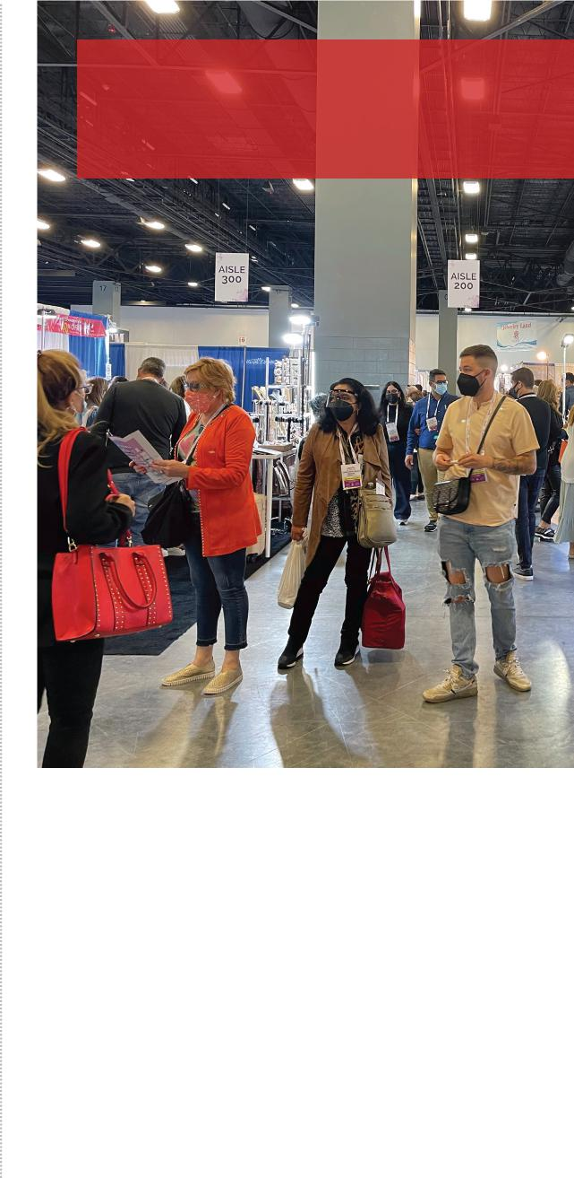
“It was our first time at the show, and our goal was finding new vendors and collections. We did some buying.”
Kylie Shaw, The Diamond Depot
checks but acknowledged that physical distancing in a booth was not always easy. She spent two full days at the show.
Despite COVID, there were many new buyers in attendance at JIS March. “It was our first time at the show, and our goal was finding new vendors and collections. We did some buying,” said Kylie Shaw, The Diamond Depot, Sandy, Utah, who has attended JCK previously. Another Diamond Depot buyer, Meggan Clark, added: “Utah was really only shut down for about a month and a half,
RX offered the technology as part of its exhibitor package. The result: 88% of exhibitors engaged with the technology, and 2,451 leads were generated via reader “taps,” said Tuchband.
Attendee Experience
As vaccine distribution ramped up across the U.S. in weeks prior to JIS, a number of attendees and exhibitors proudly reported they had been partially or fully vaccinated. Some large corporate buyers were not in attendance — due to a number of reasons, including company travel bans, medical conditions, and comfort levels around travel. But plenty of small and mid-size businesses were ready to restock their inventories for the busy spring and summer sales season after very few opportunities to do so face-to-face in the past year.
Many U.S.-based jewelry stores in tourist destinations reported strong sales during the pandemic, so they came to buy. “We bought products at 10 booths,” said Ballerini who came with her niece to buy for their family-owned business. “It’s nice to see and meet new vendors at shows. We don’t set a budget as a small business owner. It’s the beginning of the season for us, so we are buying what sells.” She appreciated the temperature

www.SISO.org | www.UFI.org 8

SISO/UFI Deeper Dive: Case Study on Jewerlers International Showcase

so we were not too badly impacted.” They were pleased with the health and safety protocols in place, especially the signage and enforcement of masks. “But some people aren’t happy about it,” Shaw said. “A vendor flew us here, and we got the ROI. No complaints from us.”
In contrast, JIS attendee buyer Sheldon Dreyfuss, Finest Direct Marketing, Fort Lauderdale, FL, said he’s come to the show for 25 years, but it was his first event to attend since the pandemic. “Doing virtual is not the answer for us,” he said. “We need to see it, touch it, feel it, and see what it looks like on someone.” He and his wife reported they are fully vaccinated. “We feel safer coming to the show because of that,” he said. “We came on the last day because we thought there would be less traffic.” His premium business has been slower during COVID. “We looked for new products and met with existing vendors,” he said.
In a normal year, JIS attracts a large contingent of international buyers from Mexico, South America, Central America, and the Caribbean. Some of those international retailers were hit hard by tourism declines and travel bans due to the pandemic. While the show focused its marketing efforts on the domestic market, JIS March did attract international buyers who made up 15% of the total attendance.
Jhoseline Flores, Gold Palace, San Juan de Los Logas, MX, a buyer for four jewelry stores, said: “Travel was easy. We had to have negative COVID test before getting on plane. We did a test at the airport.” Flores, who has attended the show for many years, reported: “We found new products, but not as many options as I’m used
to.” She is planning to attend JCK in August in Las Vegas. “I like to buy face-to-face. It’s not the same online, but that’s what we had to do during COVID. It’s not like buying a t-shirt.”
Exhibitors: Happy to be F2F
“Getting the jewelry industry back to in-person events was so important for our industry and the quality of networking, product and vendor discovery and order writing that can be done. Now more than ever, this means prioritizing health and safety for our customers and our employees, alongside the business and connections made onsite,” said Sarin Bachmann, Group Vice President of Reed Jewelry Group. “As a part of Reed Exhibitions, we have an advantage with the health and safety learnings from around the globe, and access to a large, dedicated team focused on these efforts for all of our U.S. events.”
Exhibitors who participated were glad to see current clients, but they were even more thrilled to meet new buyers. “We do a lot of business at shows,” said Michael Pavlakos with New York-based SimplexDiam Inc., who has exhibited at JIS for the past 14 years. “We missed meeting new buyers. The jewelry business has done well. Since consumers were not traveling, they were using that money to buy jewelry. Most of our buyers are small independent stores that offer service in the store, and customers wanted to support local businesses. Our sales were off last year, but not as bad as we thought they would be. COVID had an impact, but we were able to weather the storm pretty well. Day one at JIS was very full and busy all day. It was fantastic.

www.SISO.org | www.UFI.org 9

SISO/UFI Deeper Dive: Case Study on Jewerlers International Showcase

I’ve probably done 500 shows in my career, and overall, it’s been a good show.”
“Day one at JIS was very full and busy all day. It was fantastic. I’ve probably done 500 shows in my career, and overall, it’s been a good show.” Michael Pavlakos, SimplexDiam Inc.
— one was existing, and one was new. We are doing the October show (JIS), and we will advertise and promote more next time to stores in the area.”
For Inox Jewelry, a men’s jewelry brand that exhibits in 10-12 events annually, the lack of trade shows had big impact to its business. “It’s hard to have personal connections with accounts if you don’t see them face-to-face,” said Cole Roland who works in the company’s Norwalk, CT headquarters. “You lose that relationship. It’s great to be back building those relationships, seeing our customers. We like it.” What about ROI? “Absolutely worth it. Talking to customers, getting new accounts, reviving some old relationships was well worth the price of admission.”
Others agreed. “We rely on shows for new business,” said Skip Powell with Blitz, which makes jewelry cleaner for retailers. Based in
Other exhibitors reported strong sales and ROI. “It was one of the better JIS shows. I think people were tired of Zooming,” said Alex Portal, Lighting4Diamonds, Cutler Bay, FL, a 14-year-old lighting, showcase and in-store design business that has exhibited at JIS previously. “We typically exhibit in nine to 11 shows a year, so our business was impacted. We just got on the phone to try to reach customers. In this business, people want to feel the weight and magnitude. We’ve found there are a lot of retailers who are optimistic about what’s happening and the future. Buyers are willing to invest in new products, new stores, and new projects. We got the ROI on our investment at the show.”
While some companies hadn’t exhibited in a face-to-face event in more than one year, a number of companies exhibited in the Atlanta Jewelry Show (AJS), held March 6-8 at the Cobb Galleria Centre, before coming to JIS. Rebekah Anderson, Earth Pebbles Gemologist, based in Raleigh, NC, was a first-time exhibitor at JIS who exhibited at AJS in March and in October 2020. “Both were off the hook,” she said. “We had six showcases, and we had three people deep for two days. Her wholesaler business buys and refurbishes jewelry. “You really need to see, hold, and touch the jewelry in person. Each piece has its own personality. Since there were no vacations, customers wanted something special to celebrate big occasions.”
Anderson added: “We sold to two major dealers

www.SISO.org | www.UFI.org 10

SISO/UFI Deeper Dive: Case Study on Jewerlers International Showcase

Indiana, he’s exhibited since the early 90s at shows like JIS, JCK, Shot Show, RJO and Housewares. “This has been one the best JIS shows. I think it’s because everyone was anxious to get out again. There are serious buyers here. It’s good to connect with customers, and we’ve met lots of new customers. Fortunately, other industries also picked up, and we were considered an essential business because we make firearm cleaning products, too. That business skyrocketed.”
in June, and Catersource and Cabana & Capsule will be held in July.
“We’re trying to layer in a lot of pieces of business,” Peterson said. “There’s a phenomenal amount of activity right now on the event side.”
One silver lining of the pandemic: Acceleration of digital tools. “In Exhibitions, we focused on continuing to serve our customers through the disruption caused by venue closures, whilst taking appropriate steps for the future of the business, accelerating the development of digital tools, and adjusting the ongoing operating cost structure,” according to RX’s parent company RELX’s most recent financial results.
One digital tool that RX launched is a new subscription service called JCK Pro. “It’s one of the new models we are testing,” said Fischer. His message for other show organizers: “Be proud of the safety procedures you are implementing for your customers.”
“We rely on shows for new business. This has been one the best JIS shows. I think it’s because everyone was anxious to get out again. There are serious buyers here.” Skip Powell, Blitz
What’s next
The next JIS show will take place Oct. 8-11 at the Miami Beach Convention Center. The next RX show on the calendar in the U.S. is Vision Expo East, which was moved from the Jacob K. Javits Convention Center in New York to the Orange County Convention Center in Orlando. The 2021 Vision Expo East is scheduled for June 2-5. ISC West is scheduled for July in Las Vegas after postponing twice and eventually canceling its in-person show in 2020 due to the pandemic.
JCK Las Vegas and Luxury by JCK, the two trade fairs that traditionally take place at the beginning of June, have been rescheduled for August in 2021 at The Venetian Resort & Sands Expo in Las Vegas. JCK Las Vegas will take place Aug. 27-30. Luxury by JCK will take place Aug. 24-30.
The Miami Beach Convention Center hosted the Aesthetic Society, a hybrid event held April 29– May 3 after it relocated from Boston. There are no other events on the MBCC calendar in May. ITExpo and Cabana Miami are on the calendar

www.SISO.org | www.UFI.org 11

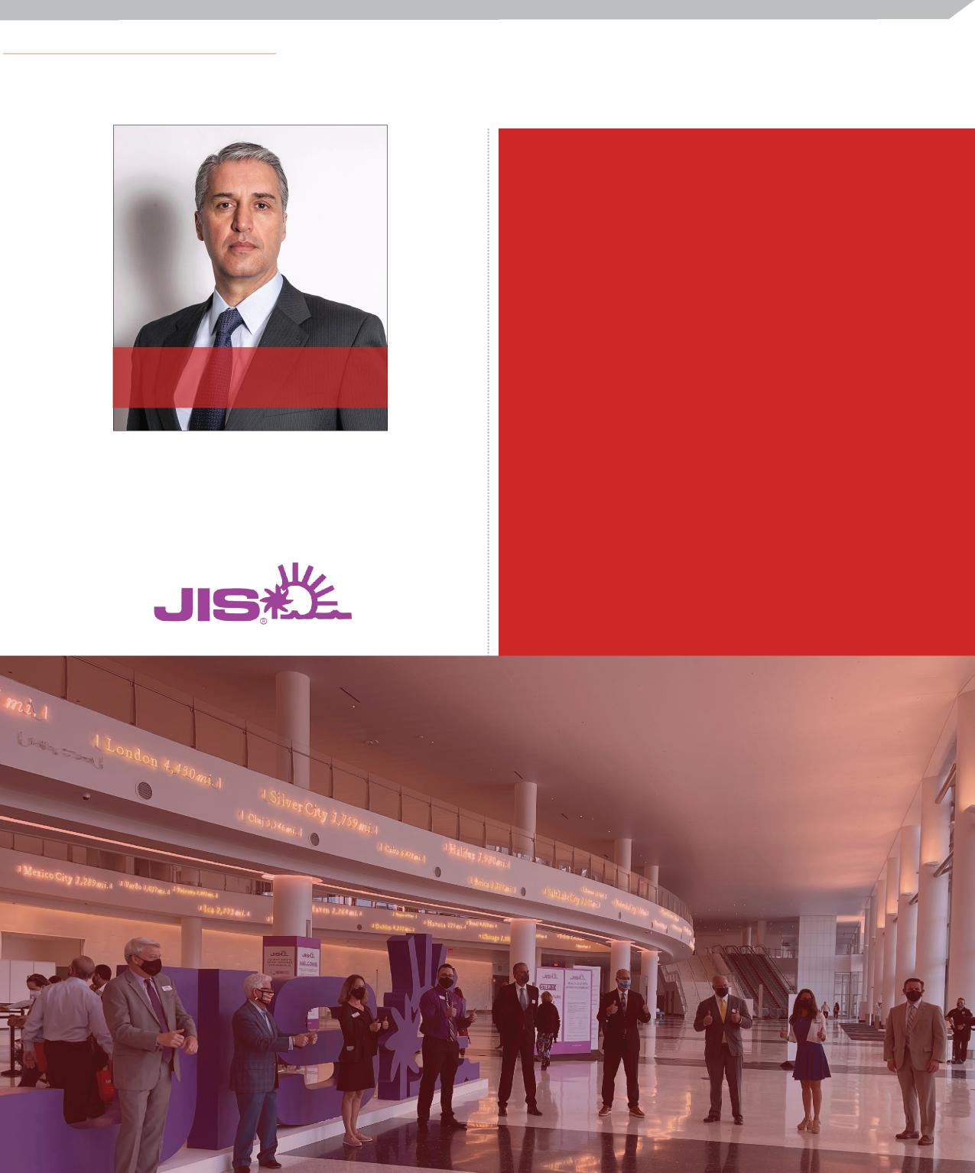
SISO/UFI Deeper Dive: Case Study on Jewerlers International Showcase
What was new and different at JIS March
- Booth occupancy limits
Fernando Fischer, President, Americas, Reed Exhibitions USA
“The good news is that 85% of our customers are booked for 2021, and we are making a push for the final 15%. We are less concerned about size and more concerned with brands and helping them to grow.”
- Security stewards to remind attendees and exhibitors to wear their masks
- Contactless registration
- Daily temperature checks and wristbands
- One entry-only door, one exit-only door for the exhibit hall
- Wider aisles and no carpeting
- F&B carts at the back of the hall, only 3 chairs per table, tall cocktails tables with no chairs
- Health & Safety Reminders on signage with a phone number to call with questions, concerns, or issues
www.SISO.org | www.UFI.org
12

SISO/UFI Deeper Dive: Case Study on Jewerlers International Showcase
About SISO – SISO members include companies, corporations and other for-profit entities that own, produce or provide full-service management of “face to face” trade shows, consumer shows, expositions, conferences and events. SISO membership is a combination of large corporations and small entrepreneurial enterprises that do business around the world. SISO’s almost 200-member companies produce thousands of events around the world. SISO’s Mission is to meet the common needs of our members by providing peer networking opportunities, education, industry information, streamlined business processes and best practices in the industry.
About UFI – The Global Association of the Exhibition Industry: UFI is the global trade association of the world’s tradeshow organisers and exhibition centre operators, as well as the major national and international exhibition associations, and selected partners of the exhibition industry. UFI’s main goal is to represent, promote and support the business interests of its members and the exhibition industry. UFI directly represents more than 50,000 exhibition industry employees globally, and also works closely with its 60 national and regional association members. More than 800 member organisations in 83 countries around the world are presently signed up as members. Around 1,000 international trade fairs proudly bear the UFI approved label, a quality guarantee for visitors and exhibitors alike. UFI members continue to provide the international business community with a unique marketing media aimed at developing outstanding face-to-face business opportunities. UFI is supporting the work of global, regional, and national institutions that deal with the COVID-19 outbreak. On this page, we are listing some resources for UFI members and the industry at large:
https://www.ufi.org/industry-resources/coronavirus/.
If you want to support our collection of case studies, please contact us:
info@siso.org and/or reopen@ufi.org
www.SISO.org | www.UFI.org 13

